DESIGN AND ANALYSIS OF ALGORITHM

LAB EXPERIMENT - 6

NAME: Ragavendar
ROLL NO: ch.sc.u4cse24260

- AVL TREE

CODE:
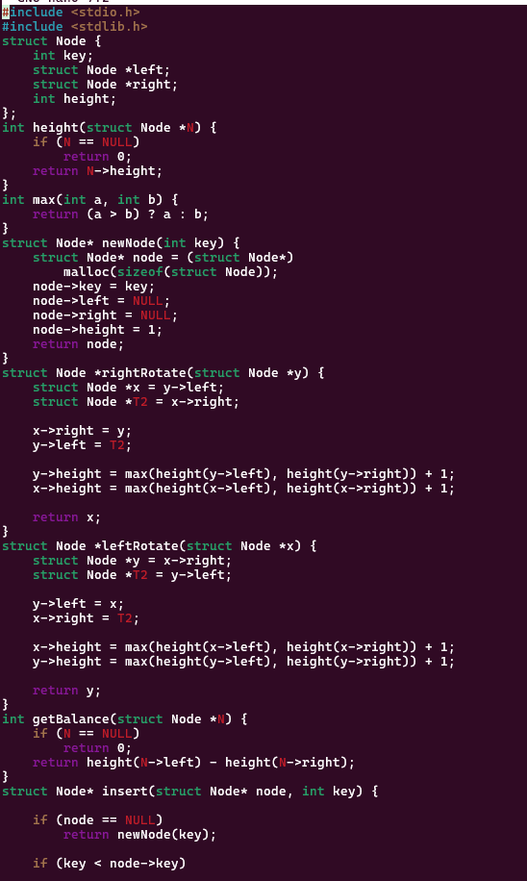

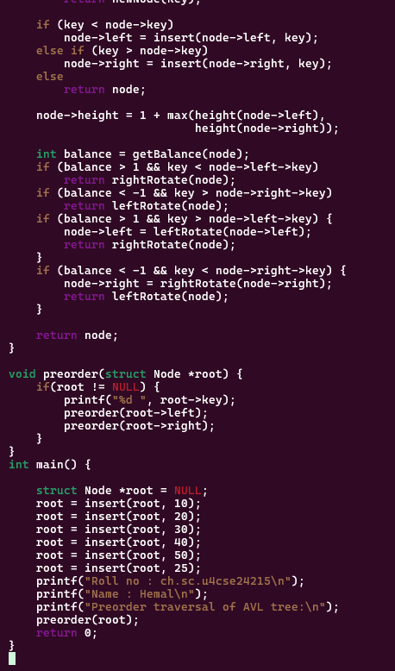

OUTPUT:
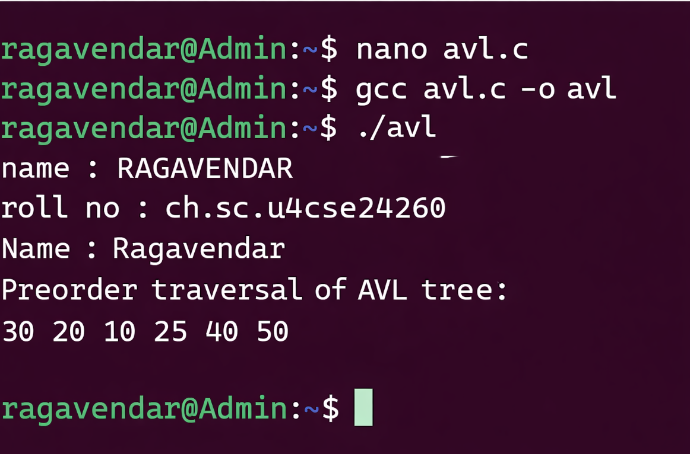
INTERPRETATION:
An avl tree is a self-balancing binary search Tree introduced by Georgy Adelson-Velsky and Evgenii Landis where the height difference between left and right subtrees of every node is at most 1.
If the balance factor becomes greater than 1 or less than −1, rotations are performed to maintain the tree balance.

- RED BLACK TREE CODE:
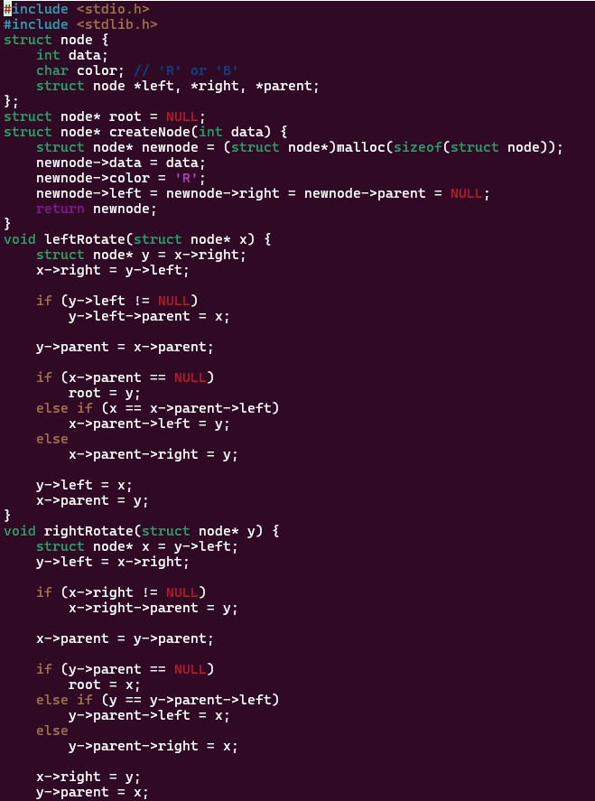

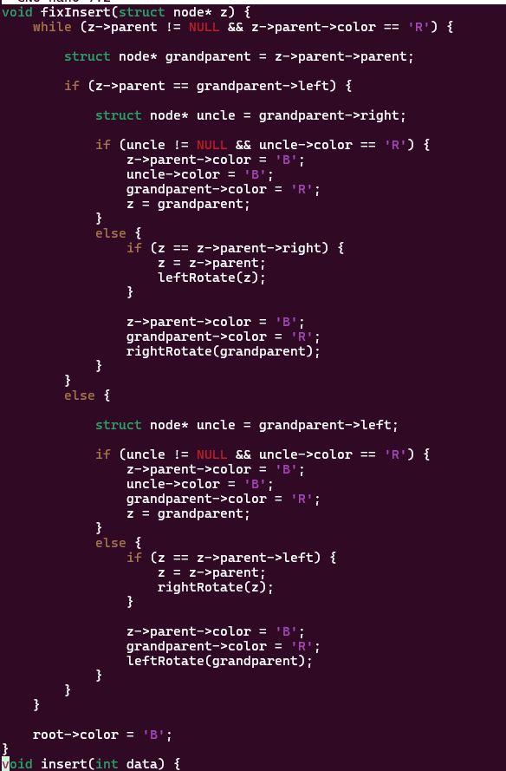

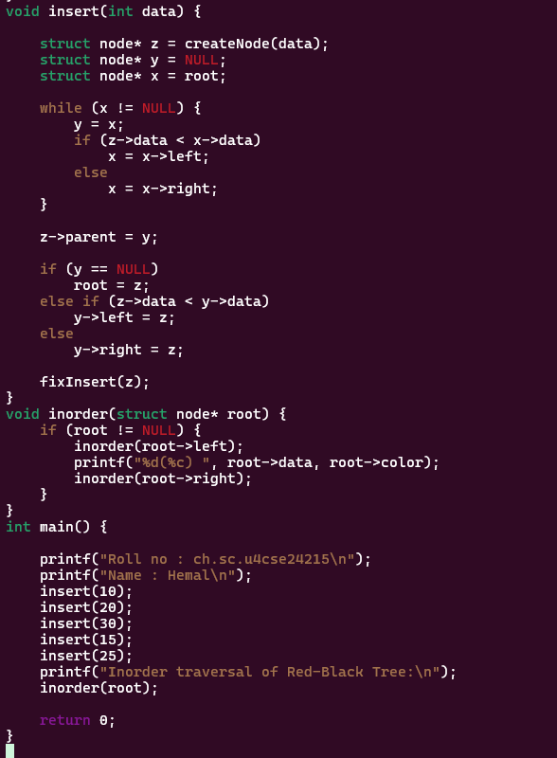

OUTPUT:
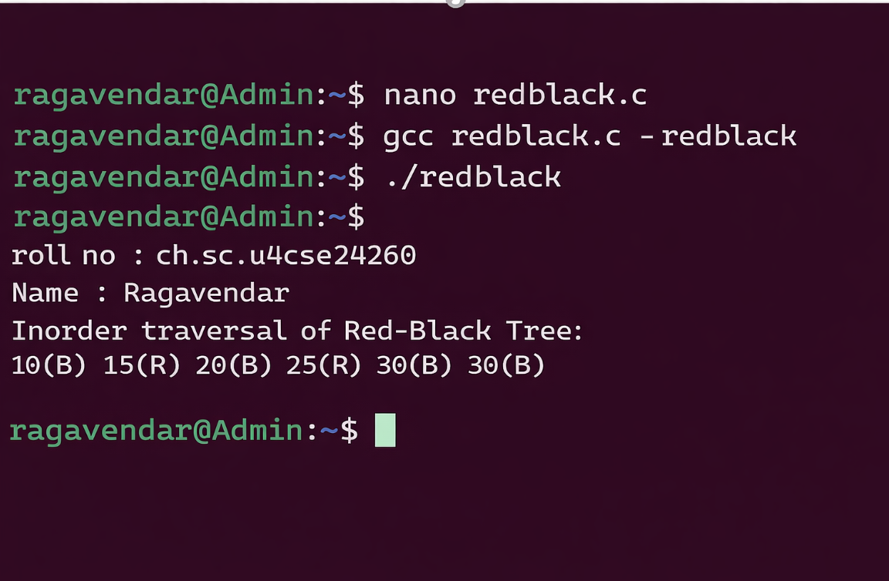
INTERPRETATION:
A red black tree is a self-balancing binary search tree in which each node is colored either red or black to maintain balance. It follows rules such as no two consecutive red nodes and the same number of black nodes on every path from root to leaf.

